INTRO

HOW THE DATABASE LOOKS LIKE

The database we are working with is a collection of 2'067'483 tweets from Twitter, posted between DATA PARTENZA to DATA STOP. The tweets deal with the topics of Covid-19 vaccines and vaccination in Italy.

For each tweet we have the following information:
- Date of the tweet
- ID code of the tweet
- Text content of the tweet
- ID code for the user posting the tweet
- Screen name for the user posting the tweet
- Place of the tweet (if specified by the user posting the tweet)
- URLs in the tweet

If the tweet is a retweet (meaning that the user has re-posted another existing tweet), we also have:
- ID of the original (retweeted) tweet
- ID of the user who posted the original (retweeted) tweet
- URLs in the original (retweeted) tweet

A subset of the dataframe consisting of 6508 tweets has also additional tags that have been assigned by people reading and interpreting the tweet as expressing an “AntiVax”, “Neutral” or “ProVax” position. We will call this feature the “polarity” of the tweet.
Depending on whether a user has tweeted (or retweeted) one or more tweets of a certain polarity, a “user polarity” is also assigned.

PREPROCESSING THE DATABASE TO BUILD A NETWORK

Our aim is to analyze the network structure composed of the users posting these tweets.

We would like to build a network in which each node represents a user and the users are linked via retweets. There is a directed edge from node A to node B if user A retweeted user B; if user A retweeted user B multiple times, the number of retweets is the weight of the edge.
Note that any tweet that does not retweet anything would not represent an edge in the network, because it would not link the author of the tweet to anyone. We drop out all the tweets that are not retweets, since we are interest in the connections between the users, so we are not interested in them

In particular, we are interested in how users from the three polarity groups (“AntiVax”, “Neutral”, “ProVax”) would connect to each other.
In our database, we have two polarity labels: the polarity label of the tweet and the polarity label of the user.
The tweet polarity label is only assigned to original tweets (not retweets), but as we said these tweets are not useful to us because because they don’t form ad edge between users.
We can instead focus on the user polarity label, which is an information about the user and not the tweet. Therefore, we keep only the tweets which belongs to users that do have a user polarity label, and drop out all the others.
It should be noted that discariding these tweets does not mean keeping only the labeled users, nor it means keeping all the labeled users.
A retweet (i.e.: row of the dataframe) bridges two users, but the “user_annotation” label on the tweet (if there is one) is associated only with the posting user, not the reposted user. This has two implications.
Firstly, even if the posting user is labeled,
WARNING: note that for each row (=tweet) we have two users, so even if the posting user is not labeled, the reposted user could be and in this way we are discarding it even if it’s labeled.
Moreso, this does not get rid of all the non-labeled users, because a labeled user could repost an un-labeled user.
Under these conditions, the number of users are:
len(antivaxxers): 461
len(provaxxers): 215
len(neutrals): 678
len(non_annotated): 2351
percentage of non_annotated user on the total : 37%
Now I will try to not drop these tweets and see the difference
len(antivaxxers): 499 8% increase
len(provaxxers): 245 14% increase
len(neutrals): 757 10% increase
len(non_annotated): 31084 1222% increase
percentage of non_annotated user on the total : 5%

With networkx [cit], we build a weighted directed network from the dataframe as described before. We attach to every user its “user polarity” as an attribute of the node.

Even having discarded the unlabeled users, this network is still pretty large, with 10'485 nodes and 75'882 edges. However, a lot of these edges have very low weight. We can think that most of the low-weigth edges do not carry that much information; they represent an occasional retweet between two users that would be otherwise unconnected. They act basically as statistical noise that would not improve our measurements. Therefore, we decide to focus only on weights larger than 2; these edges mean that two users have retweeted each other multiple times and so we can expect them to represent a meanigful connection between users.

We then take a look at the weakly connected components of this network: we can see that of all the components only one is large enough to be of any interest, filling well over 90% of the whole network. This is no surprise to us, since real world network usually show this feature [CIT].
The second largest (weakly connected) component is made of just 6 nodes and so we can drop all these small components and just keep the largest one.
At this point, we get a network with 3705 nodes and 20689 edges.

If we are curious about the strongly connected components, we can also check that we have just one large component in this case too. The largest component is made of 422 nodes, and several very small components of just a couple nodes or fewer. As we might expect, the largest strongly connected component is considerably smaller than the largest weakly connected component and it covers only 10% of the whole network.
As we will see with the centrality measures, this reflects the fact that there are some “celebrities” users, that get retweeted a lot more than most of the other users.

CENTRALITY MEASURES ON THE WHOLE NETWORK

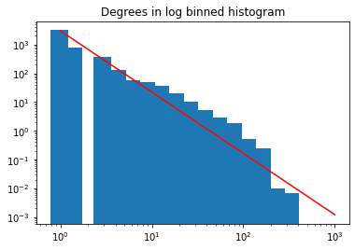

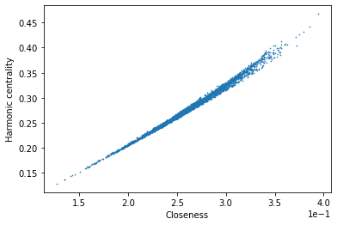
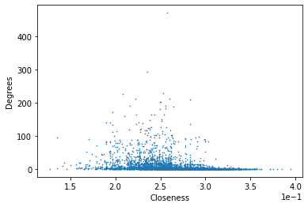

COMPARING THE MEASURES FOR THE 3 GROUPS

If we want to highlight any difference there might be among the “AntiVax”, “ProVax” and “Neutral” users, we could start by checking how the same centrality measures seen above vary from group to group.
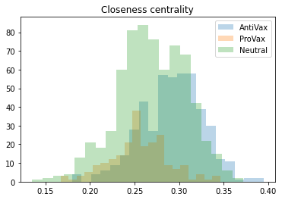
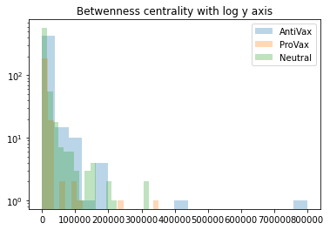

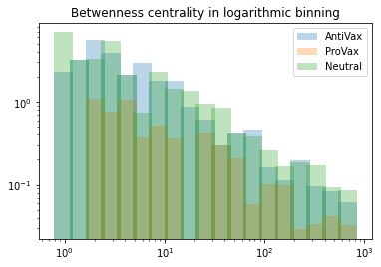
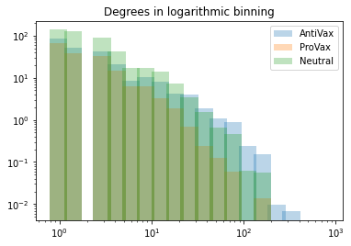

COMMUNITY DETECTION

We can take the analysis one step further introducing the concept of communities within a network. In our network we have 3 distinct types of users, “ProVax”, “AntiVax” and “Neutrals”. We might expect that these 3 types of nodes would not be connected completely at random to each other, but maybe the way the nodes are connected would highlight in a way the fact that there are 3 groups of users. It could be possible, perhaps, that nodes are more likely to be connected to nodes of the same type (this situation is known as disassortative mixing), or on the other side a node is more likely to be connected to a node of a different type (assortative mixing).
One way to check in which way these groups interact is to use a community detection algorithm in order to find subsets of the network (communities), based solely on network properties. In other word, we look at the structure of the network to infer about the presence of communities and then we compare these communities with the 3 groups we have to see how they overlap.
It might be interested to see if we can find “closed” communities, in which most or all of the users belong to the same group.

for community detection we create a undirected network from the directed one.
We measure assortativity coefficient = 0.08819015433238132 (I don't know where to put this information)

Representation of the network with colours highlighting the communities:

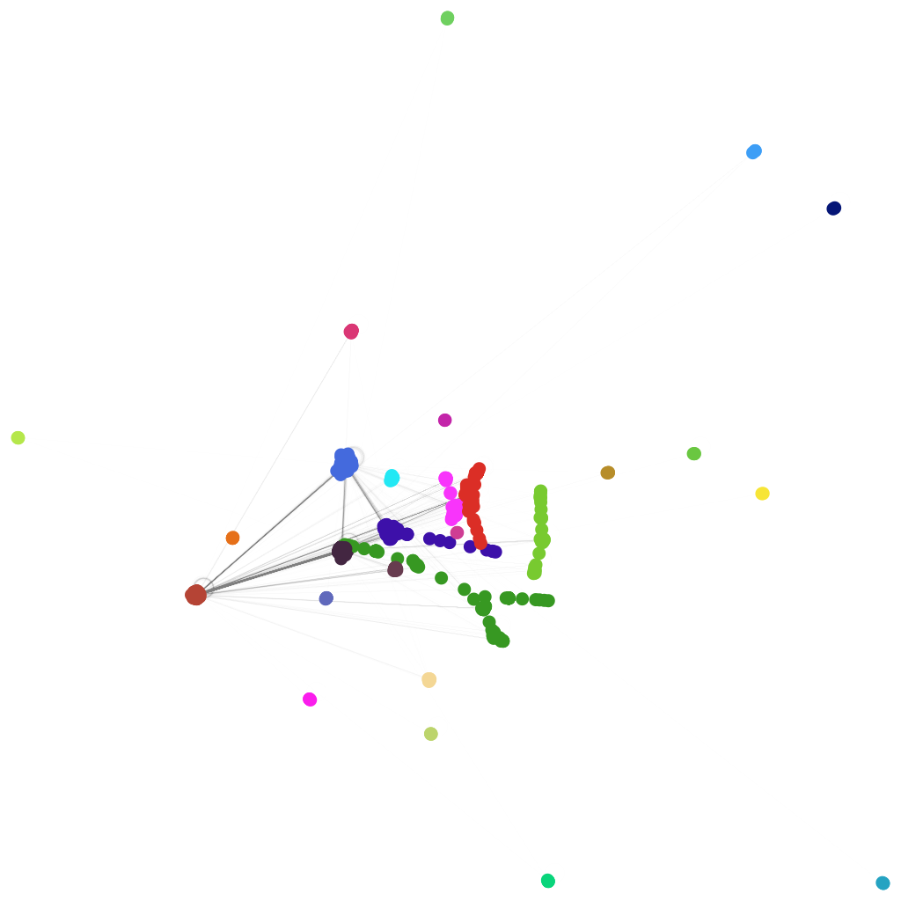

Histogram that shows for each community how many antivax/provax/etc there are (it contains the same information of the pie charts that are below, in a less clear way but in a way in which you see all the information (all the communities and all the groups) at once.
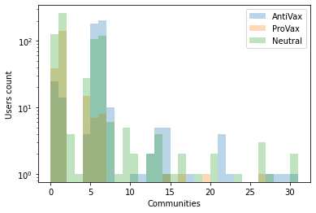

Pie charts that show how the antivaxxers, provaxxers etc are spread in the communities:
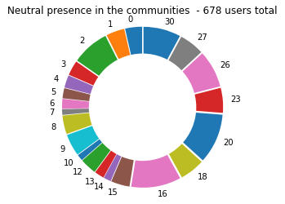
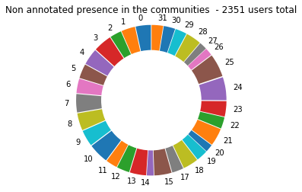
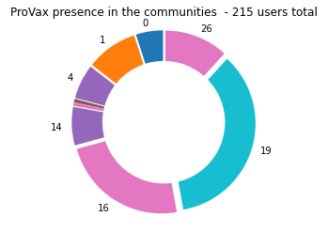
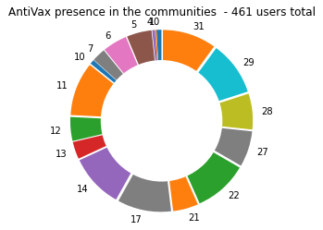

pie charts that show for each community how percentage of each group we have:

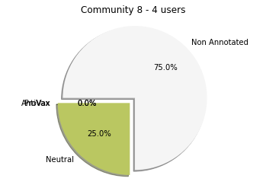
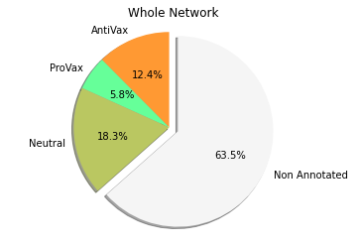

COMPARING THE MEASURES FOR THE COMMUNITIES
